**VANN VNRG  
Migration Consultants**

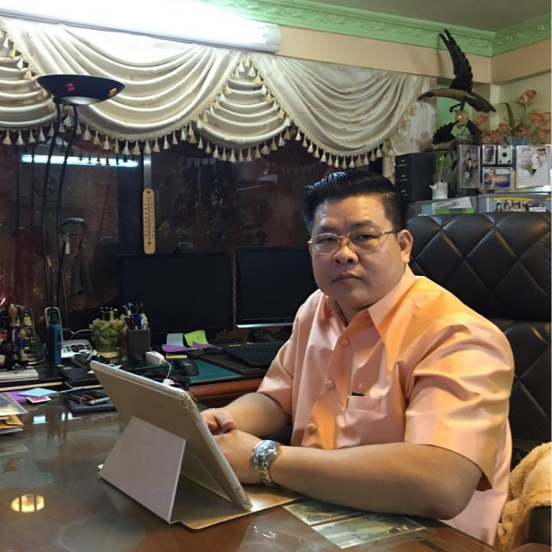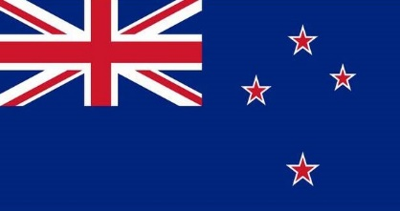

Read more

Are you looking for the right Visa?

##### Vann are specialize in the following visa

##### Employment

##### Business

##### Family

##### Study

Canada

USA

Australia

About me

Hi and welcome! I’m Vann. I am one of the leading Cambodia migration consultancy. I am providing guild-lines and advice to every situation according to individual circumstances. As registered migration agent I have dept-knowledge of international laws, regulation and policy. Migrate to international countries are extremely sophisticated, do it right at the beginning will save your money and time. I have established my business since 2000. 17 years of experience you will confident on my work, I will simplify processes into short summary you can just sit back and relax and I will work with immigration department.

Services

BOOK NOW

My story:

I was graduated in the University of Cambodia. I was planning to continue my study in Australia however, I didn't have much idea what to do?

After I met with Mr Vann he has provided information about my study. I have used his service and I am extremely satisfied because he has organized and support me with every procedure to get my student Visa.

Now I am in Adelaide and I am still in touch with him for further assistance.

Story

Book Now



**Planning to go oversea?**

**Unknowing what to do?**

*It is our priority to help you*

Service

Contact

About

Home

New Zealand

HOW I CAN   
HELP YOU

Describe your service here. What make it great? Use short catch text to tell people what you offer, and the benefits they will receive. A great description gets readers in the mood, and makes them more likely to go ahead and book.

Successful Applicants Rate

99 %

BOOK NOW

Contact

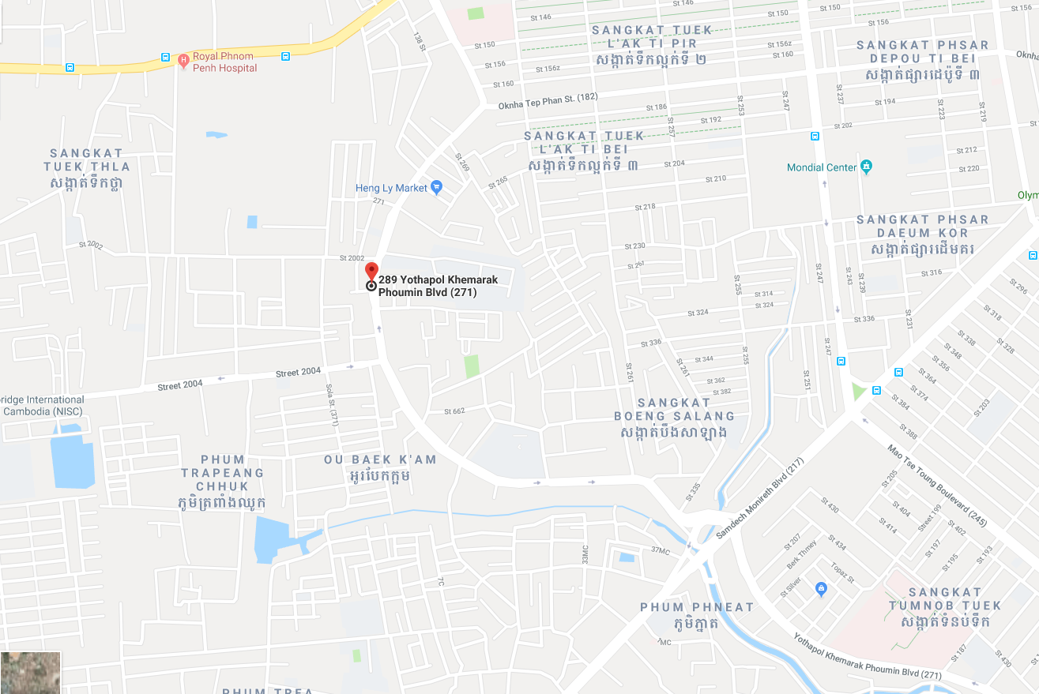`

## VORNG VANN

Visit Address:

#35Eo, Street 271, Sen Sok

PO BOX: 573, Phnom Pench, Cambodia

Call:

Tel: (855) 012 507171 / 070 507171

Contact: [visas.centre@gmail.com](mailto:visas.centre@gmail.com)

Website: [vorngsovann.com](mailto:info@mysite.com).kh

SEND

Message

EMAIL

SUBJECT

NAME

VONRG VANN

Migration Consultants

VONRG VANN

Migration Consultants

VNRG VANN

Migration Consultants

VNRG VANN

Migration Consultants